**Definition: Design invitation card using photoshop layers.**

**Solution:**

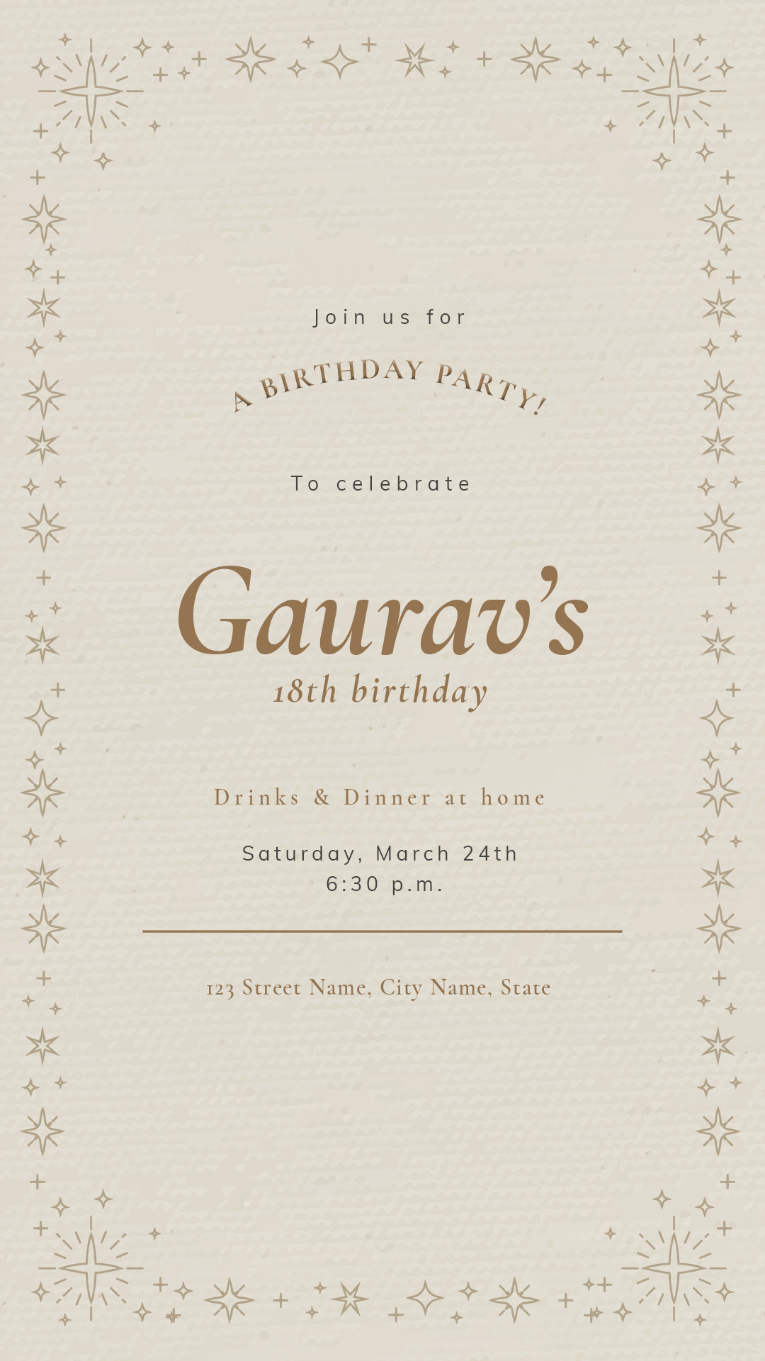

**Steps:**

* First Open photoshop.
* Then create the new document **File à New Photoshop Design.**
* Now add take one frame using the Frame tool and select a Desktop frame of width=”**1080 px**” and height=”**1920 px**” on your canvas.
* Take an image with designed border.
* Now take Horizontal Type Tool and write “**Join us for**” of font=”**Muli**”, font size=”**7 px**” and color=”**#444341**”.
* Unter the text write “**A BIRTHDAY PARTY!**” of font=”**Cormorant Garamond**”, font size=”**9 px**” and color=”**#947450**”.
* Now write “**To celebrate**” of font=”**Muli**”, font size=”**7 px**” and color=”**#444341**”.
* Write “**Gaurav’s 18th birthday**” of font=”**Cormorant Garamond**”, font style=”**Bold italic**” and color=”**#947450**”.
* Unter the text write “**Drinks & Dinner at home**” of font=”**Cormorant Garamond**”, font size=”**8 px**” and color=”**#947450**”.
* Now write “**T Saturday, March 24th 6:30 p.m.**” of font=”**Muli**”, font size=”**7 px**” and color=”**#444341**”.
* Draw a horizontal line of width=”**217 px**”, height=”**1 px**” and color=”**#947450**”.
* Write “**123 Street Name, City Name, State**” of font=”**Cormorant Garamond**”, font style=”**Bold italic**” and color=”**#947450**”.
* Now, Go to **File à Save As** and save it with **.PSD/.JPEG/.PNG** format.